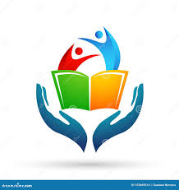***VACSI works in over 50 countries and territories to save children’s lives, to defend their rights, and to help them fulfil their potential, from early childhood through adolescence. And we never give up.***

**Child protection and inclusion**

Every child has the right to grow up in a safe and inclusive environment

VACSI works with partners around Africa to promote policies and expand access to services that protect all children.

**Child survival**

Every child has the right to survive and thrive

VACSI has helped reduce child mortality all over Africa by working to reach the most vulnerable children, everywhere.

**Education**

Every child has the right to learn

VACSI works around the world to support quality learning for every girl and boy, especially those in greatest danger of being left behind.

## Social policy

#### Every child has the right to an equitable chance in life

VACSI works around the world (Especially in Africa) to reduce child poverty and shield girls and boys from its lifelong consequences.

**Research, evidence and analysis**

 Using data and evidence to drive results VACSI’s global programmes and initiatives are grounded in rigorous research and thoughtful analysis about the situation of children.